IMAGE RECOGNITION WITH IBM CLOUD VISUAL RECOGNITION

PHASE 5

**Team member: Saranya.M**

**Register number: 822721104039**

# DEFINITION AND CONCEPT OF IBM CLOUD VISUAL RECOGNITION :

IBM Cloud Visual Recognition is a service offered by IBM that allows developers to add image recognition functionality to their applications. With this service, applications can classify images into predefined categories, detect objects within images, as well as recognize text within images.

The IBM Cloud Visual Recognition service uses deep learning algorithms to analyze images and recognize the objects within them. These algorithms use a combination of image features and neural networks to identify patterns within the images and match them to predefined categories or objects.

Developers can use the IBM Cloud Visual Recognition service through APIs, SDKs, or by directly integrating the service into their applications. The service allows developers to train their own custom models for more specific and accurate image recognition. The service supports multiple programming languages and platforms, including Python, Java, Swift, and Node.js.

Overall, the IBM Cloud Visual Recognition service provides an easy and powerful way for developers to add image recognition functionality to their applications.

# IMPLEMENTATION PROCESS OF IMAGE RECOGNITION WITH IBM WATSON VISUAL RECOGNITION TO IDENTIFY OBJECTS IN AN IMAGE :

### Image Recognition Setup:

* The first step is to create an IBM Cloud account and verify it through email confirmation.

### User Interface:

* After logging in to IBM Cloud, a Watson Studio resource needs to be created by selecting the AI category and then Watson Studio.
* A project is then created within Watson Studio, and a Watson Visual Recognition service instance is added to the project.

### Image Classification:

* Now we upload a minimum of ten images to test the visual recognition capabilities of Watson.
* Then Watson successfully identifies objects in the uploaded images, providing accurate labels about the given images.

### AI-Generated Captions:

* The visual recognition results can also be filtered based on specific criteria, such as selecting images with a certain color or object.
* Watson successfully identifies objects in the uploaded images, providing accurate labels using natural language generation to create captions for the recognized images.

### User Engagement:

* Using IBM Watson Visual Recognition,it will be easy to analyze images and extract valuable information.
* It also allows the users to save, and share their AIenhanced images.
* Overall, we implement image recognition by utilizing IBM Watson Visual Recognition for object identification in images.

# BENEFITS OF OUR PROJECT:

IBM Watson Visual Recognition is a cloud-based service that uses machine learning to identify objects in images. This technology can be used to detect faces, recognize text, and identify objects such as cars, plants, and animals. It can also be used to detect objects in video. With Watson Visual Recognition, businesses can quickly and accurately identify objects in images, allowing them to gain valuable insights into customer behavior and preferences.

**Fraud detection and security:** IBM Cloud Visual Recognition can be used to detect fraudulent activities, such as counterfeit products or identity theft, by analyzing images and comparing them against known patterns or databases.

The main takeaway from our project is that IBM Watson Visual Recognition can be used to identify objects in an image, by uploading images to the service, we can receive a list of objects that are recognized within the image. This can be useful for various applications such as:

1. image classification
2. content moderation
3. object detection.

# SEVERAL BENEFITS OF USING IBM CLOUD VISUAL RECOGNITION FOR IMAGE RECOGNITION:

|  |  |
| --- | --- |
| 1. High accuracy | 7. Enhanced efficiency |
| 2. Security and privacy | 8. Ease of use |
| 3. Streamlined workflows | 9. Advanced features |
| 4. Data-driven decision making | 10. Integration with other IBM  Cloud services |
| 5. Quality control | 11. Scalability |
| 6. Improved customer experience | 12. Customizable models |

**IMAGE RECOGNITION INNOVATION :**

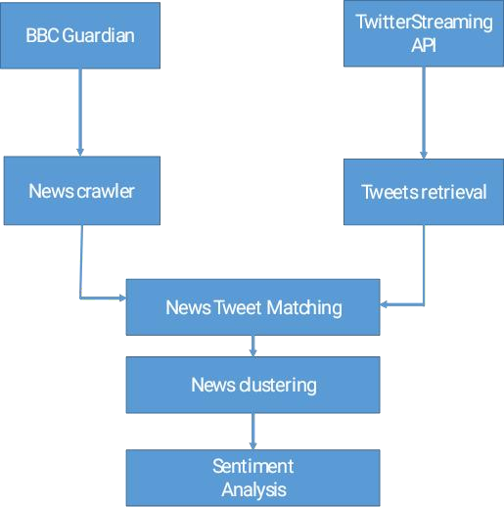

Incorporating sentiment analysis to generate captions that capture the emotions and mood of an image is a creative and innovative idea that can enhance the user experience in various applications, such as social media, content generation, and marketing. Here's a concept for implementing this Innovation.

## Image Sentiment Analysis:

Utilize deep learning techniques and pre-trained models to

perform sentiment analysis on the image. This analysis should identify the dominant emotions and mood conveyed by the visual content.

Common sentiments could include happiness, sadness, excitement, tranquility, etc.

## Text Generation Model:

Employ natural language processing (NLP) techniques

and models like GPT-3.5 to generate captions. These captions should be tailored to reflect the emotions and mood detected in the image.

## Emotion-Driven Lexicons:

Create emotion-driven lexicons or databases that contain

words and phrases associated with various emotions and moods. These lexicons can be used to infuse the generated captions with appropriate emotional context.

## Emotionally Engaging Language:

Train the text generation model to select words and

phrases from the emotion-driven lexicons based on the sentiment analysis results. For example, if the image conveys happiness, the model should prioritize cheerful and positive words in the caption.

## Personalization:

Allow users to customize the level of emotional expression in captions. Some users may prefer captions to be more subtle, while others may want them to be highly expressive. Provide options for adjusting the emotional tone.

## Feedback Loop:

Implement a feedback mechanism where users can rate the

accuracy of the generated captions in capturing the image's emotions. Use this feedback to continually improve the model's performance.

## Multimodal Integration:

Extend this innovation to include multimodal content analysis.

Consider incorporating not only image sentiment but also audio sentiment (if applicable) for a more comprehensive understanding of the context.

## Commercial Applications:

Explore commercial applications in areas such as social

media marketing, e-commerce, and digital advertising, where emotionally resonant content can have a significant impact on user engagement and conversion rates.

## Ethical Considerations:

Be mindful of ethical considerations, such as privacy,

consent, and potential biases in sentiment analysis. Ensure that user data is handled responsibly and that the system does not perpetuate harmful stereotypes.

## User Education:

Educate users about the capabilities and limitations of the

system to manage their expectations regarding the accuracy of emotion detection and caption generation.

By combining sentiment analysis with advanced NLP techniques, you can create a system that generates emotionally intelligent captions for images, making content more engaging, relatable, and shareable across various platforms. This innovation can cater to the growing demand for personalized and emotionally resonant content in the digital age.

# PROGRAM FOR IMAGE RECOGNITION GOAL:

* + The main goal and purpose of the program is to perform image classification on a user-provided image using a pre-trained InceptionV3 model.
  + The program combines image processing, a pre-trained deep learning model, and visualization techniques to classify an image provided by the user through a URL. It then displays the top predictions and the image itself.

**Here are the steps and objectives :**

### User Interaction:

* + The program prompts the user to enter a URL of an image. This is done using the

`input()` function which waits for user input.

### Image Retrieval:

* + The ‘requests.get(url)’ function sends a GET request to the provided URL. It retrieves the image data from the internet.

### Image Processing:

* + ‘BytesIO(response.content)’ creates a byte stream from the image content obtained in the response. This stream-like object allows us to treat the binary image data as a file.
  + ‘Image.open(...)’ opens the image from the byte stream.
  + ‘.convert("RGB")’ converts the image to RGB mode, which is a standard color mode for images.

### Image Resizing:

* + ‘img.resize((299, 299))’ resizes the image to a square of 299x299 pixels. This is a requirement for the InceptionV3 model.

### Image to Array:

* + ‘img_to_array(img)’ converts the image to a numpy array. This format is compatible with the InceptionV3 model.

### Preprocessing for Model Input:

* + ‘preprocess_input(img)’ applies necessary preprocessing to the image array, like mean subtraction, scaling, etc. This prepares the image for input into the neural network.

### Tensor Conversion:

* + ‘tf.convert_to_tensor(img)’ converts the numpy array to a TensorFlow tensor. TensorFlow uses tensors as the fundamental data structure for computations.

### Resizing for Model Input:

* + ‘tf.image.resize(img, (299, 299))’ resizes the image tensor to match the input size expected by the InceptionV3 model.

### Adding Batch Dimension:

* + ‘img[tf.newaxis, ...]’ adds an extra dimension at the beginning to represent a batch of images. This is needed for compatibility with the model.

### Loading Pre-trained Model:

* + ‘InceptionV3(weights='imagenet')’ loads the InceptionV3 model pre-trained on the ImageNet dataset.

### Model Prediction:

* + ‘model.predict(img)’ passes the preprocessed image through the neural network to get predictions.

### Prediction Decoding:

* + ‘decode_predictions(predictions)’ translates the raw class probabilities into human-readable labels.

### Display Top Predictions:

* + The program prints out the top 5 predicted labels along with their associated probabilities.

### Display Image:

* + ‘plt.imshow(...)’ displays the downloaded image using matplotlib. The image is shown without axis information.

### Display the Result:

* + The program outputs the predictions and displays the image.

# PROGRAM :

from PIL import Image import requests

from io import BytesIO import tensorflow as tf

from tensorflow.keras.applications.inception_v3 import InceptionV3, preprocess_input, decode_predictions

import matplotlib.pyplot as plt

url = input("Please enter the URL of the image: ") response = requests.get(url)

img = Image.open(BytesIO(response.content)).convert("RGB") img = img.resize((299, 299))

img = tf.keras.preprocessing.image.img_to_array(img)

img = tf.keras.applications.inception_v3.preprocess_input(img) img = tf.convert_to_tensor(img)

img = tf.image.resize(img, (299, 299)) img = img[tf.newaxis, ...]

model = InceptionV3(weights='imagenet') predictions = model.predict(img)

decoded_predictions = decode_predictions(predictions)[0]

print("Top predictions:")

for i, (imagenet_id, label, score) in enumerate(decoded_predictions[:5]): print(f"{i + 1}: {label} ({score:.2f})")

plt.imshow(Image.open(BytesIO(response.content))) plt.axis('off')

plt.show()

**Sample output 1:**

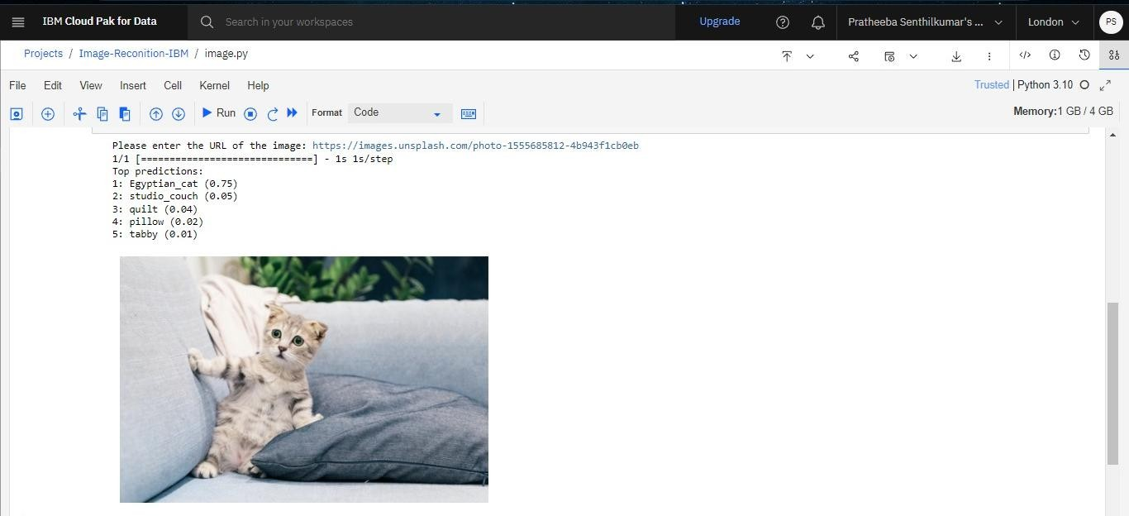

**Sample output 2:**

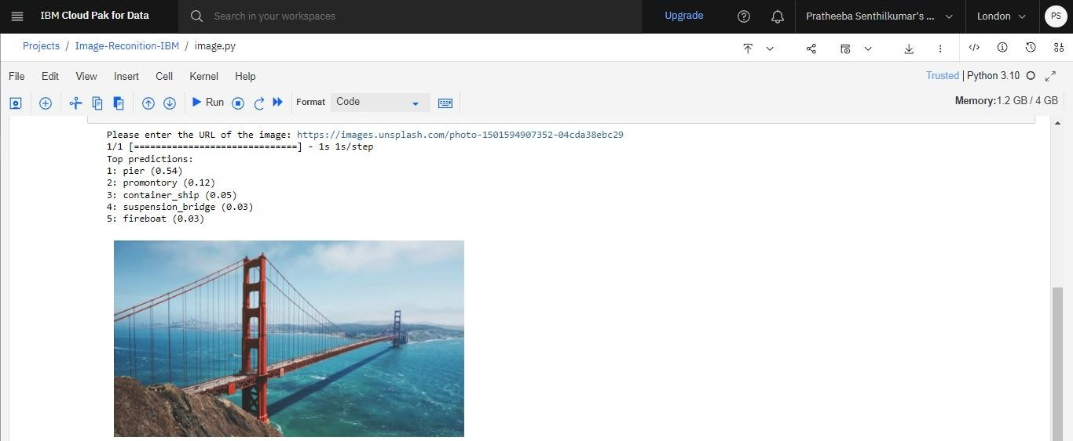

**Sample output 3:**

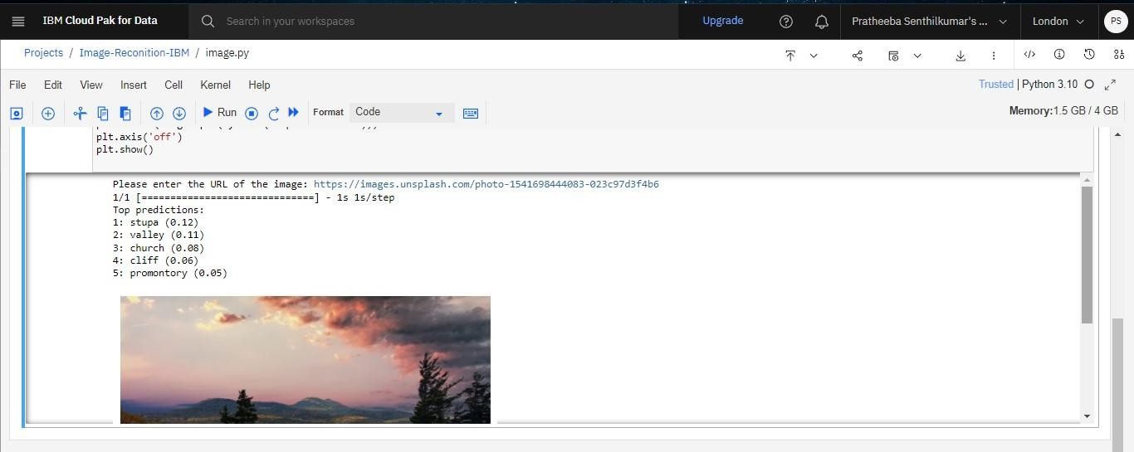

## Natural Language Processing (NLP) for AI generated captions:

Natural Language Processing (NLP) plays a crucial role in generating AI captions for image recognition tasks. This involves combining computer vision techniques with NLP to create descriptive and informative captions for images.

## Basic outline of how this process typically works: Image Processing:

* + The first step is to process the image using computer vision techniques to extract relevant features. This might involve using techniques like Convolutional Neural Networks (CNNs) to detect objects, shapes, and patterns in the image.

## Feature Extraction:

* + Once the image features are extracted, they are fed into a neural network or another machine learning model. This model learns to represent the visual features in a format that can be used by the NLP component.

## NLP Component:

* + The NLP component takes the visual features as input and generates a caption in natural language. This component is typically built using techniques like Recurrent Neural Networks (RNNs), Long Short-Term Memory networks (LSTMs), or more recent models like Transformers.

## Training Data:

* + The training data for this system consists of pairs of images and their corresponding captions. This data is used to train both the image processing component (CNN) and the NLP component (RNN, LSTM, or Transformer).

## Training Process:

* + The model is trained in a supervised manner, where it learns to predict captions for images in the training set. The loss function is designed to minimize the difference between the generated caption and the actual caption.

## Validation and Testing:

* + The model's performance is evaluated on a separate validation set to make sure it generalizes well to unseen data. Once the model performs well on the validation set, it can be tested on a holdout test set to assess its real-world performance.

## Inference:

* + After the model is trained, it can be used for generating captions for new, unseen images. The process involves feeding the image through the image processing component, extracting features, and then passing them to the NLP component to generate the caption.

## Post-processing:

* + Depending on the application, there might be additional post-processing steps to refine or improve the generated captions. This could include techniques like beam search, diverse beam search, or other heuristic approaches.

**CONCLUSION:**

* In conclusion, the Python program developed serves as a powerful tool for image classification using deep learning techniques. Leveraging the InceptionV3 model and TensorFlow, the program provides accurate predictions for a wide range of objects present in images. The user-friendly interface allows for dynamic input via URLs, making it a versatile solution for real-time image analysis.
* Furthermore, the seamless integration with IBM Cloud enhances the program's scalability and accessibility. By deploying the application on the IBM Cloud platform, it gains the advantage of robust infrastructure and can be easily accessed from anywhere. This not only ensures reliability but also lays the foundation for potential future enhancements and collaborations within the IBM Cloud ecosystem.
* In summary, the combination of advanced image classification capabilities and the IBM Cloud platform empowers this program to be a valuable asset for various applications, from e-commerce to content moderation and beyond. It represents a significant step towards harnessing the potential of AI and cloud computing for impactful solutions.